
State of Rhode Island and Providence Plantations
Department of Human Services
Office of Rehabilitation Services
Adaptive Telephone Equipment Loan (ATEL) Program
40 Fountain Street ~ Providence, RI 02903
401-462-7857 ~ 401-222-3574 FAX ~ TTY (401) 222-1679

Technology and Communication Strategies
for Persons with Hearing Loss
Next Meeting – March 11, 2015
(And continued on the 2nd Wednesday of each month, except August)
.
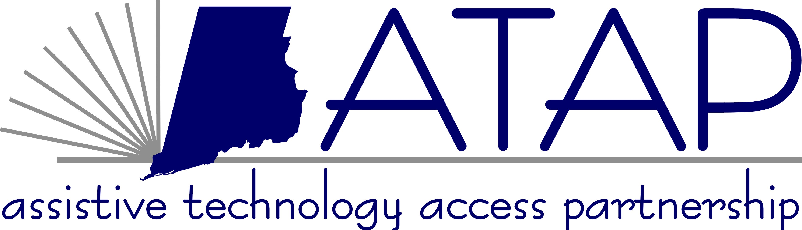
This demonstration is presented at TechACCESS of RI by
Denise Corson, ATEL Program Coordinator, and
Courtenay Petracca, Outreach Coordinator RI Relay, Hamilton
Melissa Rosenberg, OSCIL, Independent Living/AT Specialist

Technology and Communication Strategies for Persons with Hearing Loss is a demonstration that helps Hard of Hearing individuals move from isolation to independence, by:

- Learn about the latest technology – hearing aids, amplified phones, CapTel phones, cochlear implants, captioning, hearing assistive technology, and more – all to help you live well with hearing loss.
- Learning about supportive organizations where people with all degrees of hearing loss come together to share and learn – and where it’s okay not to hear well.
- Talk with others who have hearing loss.
- Learn about advocacy and the laws that protect you, and find out about local resources.
- Learn about where to purchase these items and funding options.
- See how a hearing-friendly environment works to help you with your hearing loss.

All attendees can loan out equipment, on a first come first service basis, to see if the equipment is appropriate for their needs. Also, qualified attendees can apply for a FREE telephone thru the ATEL Program.

Location: TechACCESS
110 Jefferson Boulevard, Suite I, Warwick, Rhode Island
Time: 5:00 to 6:00 PM - view and demonstrate ATEL telephone equipment only.
6:00 to 8:00 PM- Technology and Communication Strategies
for Persons with Hearing Loss
These workshops are free, no registration is required. CART Services will be provided; however, if you need any other special accommodations, please call 3 weeks in advance.

Inclement Weather Policy
Please note that if the local news reports that there is either business or school closing in Warwick due to weather, then the demonstration is cancelled and will reconvene the following month.

For more information, call 401-463-0202 (V/TDD), in state 800-916-8324

